**Java Environment Configuration**

To use Java as a developing language, environment configuration is the first step, among which JDK(Java Development Kit) is the most important. JDK configuration needs to be conducted based on different environment, such as Windows，MacOs，linux etc, Please see below the procedures for different operating systems.[click here to download JDK 8.0](https://www.oracle.com/technetwork/java/javase/downloads/jdk8-downloads-2133151.html). Now we will take MacOS as example to show you how to configure JDK environment.

**JDK configuration for Mac operating system**

1. Download JDK for MacOs.
2. Click to install and finish the installation.
3. Use java -version command to check the version information. If the output is shown in the appropriate version, the installation has been done successfully.
4. If there is no corresponding version or Java commands cannot be recognised, please configure environment variables. For reference please visit (<http://www.cnblogs.com/quickcodes/p/5398709.html>)

**JDK configuration for other operating systems**

* [Windows system configuration](https://docs.oracle.com/javase/8/docs/technotes/guides/install/windows_jdk_install.html)
* [Linux system configuration](https://docs.oracle.com/javase/8/docs/technotes/guides/install/linux_jdk.html)

**Hello World**

Progamming learners always makes the first step by designing the "Hello World" programme. Now it's your turn to write the first Java programme in your life - HelloWorld.

1. Create a new folder for your programming, eg. JavaWorkSpace.
2. Create a file under the new folder - HelloWorld.java.
3. Open the new file using notepad or VIM, and add below codes:

**public** **class** **HelloWorld** {

**public** **static** **void** **main**(String[] args) {

*// Prints "Hello, World" in the terminal window.*

System.out.println("Hello, World！");

}

}

1. Save and exit.
2. Open command terminal under the current folder.
3. Execute the command: javac HelloWorld.java，This command will compile this Java file into a class file. As a result, you will find a new class file under the current folder.

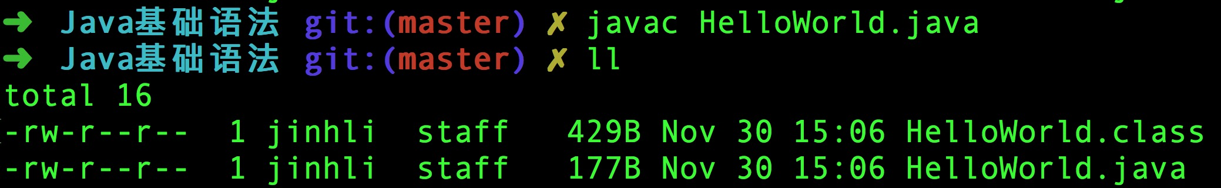7. Execute java helloWorld. This is a command to execute the compiled file. If everything goes well, you will see the output "Hello, World！" from the console.



**Development tools**

There is nothing wrong to write codes using notepad or command lines. But its low efficiency is really annoying. The saying goes "A workman must first sharpen his tools if he is to do his work well". Likewise, a good Integrated Development Environment(IDE) can greatly improve efficiency. Below are some of the common IDE I recommend:

[**Eclipse**](https://www.eclipse.org/)

Eclipse is a well known free and open cross-platform IDE, which is mainly used for Java language programming. As a framework plaform, Eclipse is nothing special. But when supported by multiple plug-ins, Eclipse will become quite flexible.Many software developers use Eclipse as a framework to develope their own IDE. If your computer configuration is not up to standard, you can use Eclipose for programming.

* [Download from here](https://www.eclipse.org/downloads/)
* [Getting started](https://www.eclipse.org/getting_started/)

[**IntelliJ IDEA**](https://www.jetbrains.com/idea/)

This is a very elegant and powerful development tool. I personally highly recommend it. To know more about its features, please refer to[here](https://www.jetbrains.com/idea/features/); It has a community and a flagship version.Targeted at Java developer enthusiasts, the community version is for free and open source. Flagship version is for enterprise development and has to be bought. In general, the community version is enough for starters.

* [Please download it here](https://www.jetbrains.com/idea/download)
* [Getting started](https://www.jetbrains.com/idea/documentation/)
* [Guide on shortcut key](https://codingstyle.cn/topics/241)